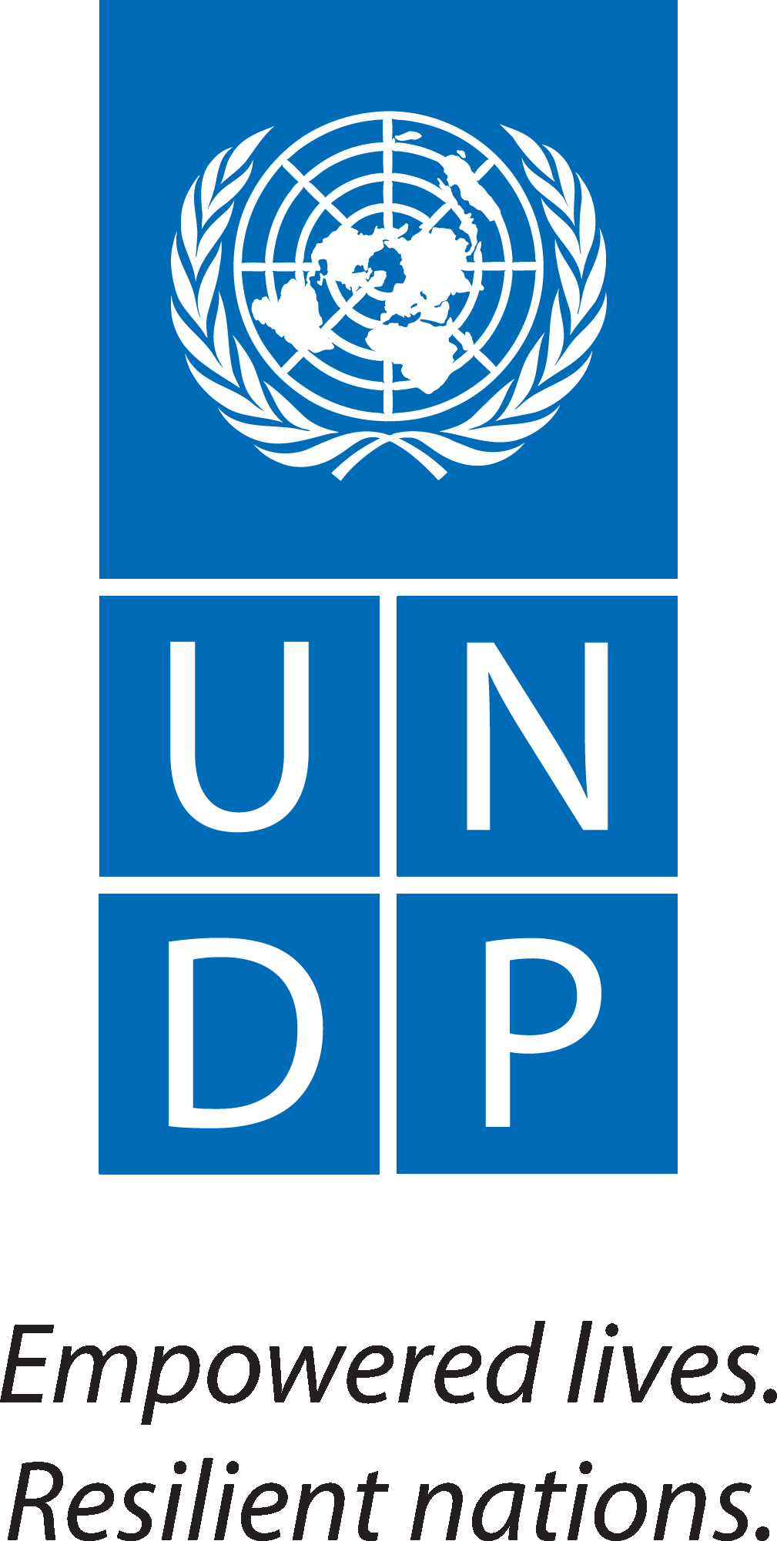
Country: Liberia

Title of Project | Support to Coordination of emergency response against the Ebola Viral haemorrhagic fevers epidemic.
UNDAF 2013-2017: Pillar III Human development | UNDAF Pillar III Human Development
Outcome 3.3 Social Protection: Vulnerable households and groups benefit from appropriate social protection services and systems. | Strategic linkage: Improving social service capacities nationally and at county level, with the participation of communities.  "By 2017, the general population and in particular the most vulnerable have access and use comply with the standards and international and national standards of basic social services to improve their living conditions".
The Implementation Partner (IP) | UNDP (Direct Execution- DEX)
Responsible Partners (RPs) | Ministry of Health, Ministry of Internal Affairs, WHO, UNMIL UNICEF  Non-Governmental organizations
The overall objective of the project is to improve the response capacity of the Government of Liberia and its partners to the epidemic of viral hemorrhagic fever Ebola.
The specific objective of the project is to; Strengthen the coordination of the emergency response at all levels.

The Government is committed to reinforce the global response and coordinate all activities to manage and contain the spread of the Ebola virus. To this end, the national Humanitarian Assistance Committee (HAC) has developed a plan for emergency response with a focus on strengthening Coordination at the National, Regional and County levels; intensify the monitoring of active cases (active case-finding and searching of contacts); provide rapid support and effective control of infection and public health, communication/awareness, management of the body and the safety of injections.

The UN country team led by WHO, and the UN Mission in Liberia (UNMIL) is working closely with development partners including international Non-Governmental Organizations to support the Government of Liberia (GoL) to bring the epidemic under control.
Programme Period: May -July 2014  Project Title: Assistance for the Coordination of the emergency response against the hemorrhagic viral Ebola Fever in Liberia  Project ID: _________________  Project Duration: Three (3) Months  Management Arrangement: DEX | Total Budget: 2,175,000 USD  Allocated Resources (None):  TRAC 1.13: 181,620 USD

Agreed by (UNDP):_____________________________________________________________

SITUATIONAL ANALYSIS

Viral hemorrhagic fever due to the Ebola virus is a contagious disease that manifests as a fever accompanied by diarrhea, vomiting, and intense fatigue and bleeding sometimes. Transmission occurs by direct contact with individuals or infected animals.

The Ebola Virus Disease (EVD) is reported to have entered Liberia from the Republic of Guinea, where the disease has claimed more than a 100 lives and few hundreds of reported cases have been recorded. Since its arrival in Liberia the GoL has taken pragmatic steps to control the epidemic with the support of the international community and the UN Mission and Country team. Liberia’s Ministry of Health & Social Welfare MoHSW), on 30 March 2014, confirmed two cases of Ebola in Foya District, Lofa County.
The World Health Organization (WHO) and Ministry of Health and Social Welfare (MoHSW) are actively working in the region to contain the possible spread of the disease, and to educate the public about prevention. A team comprising MoHSW and WHO officials, along with the Chief Medical Officer of UNMIL, travelled to Voinjama and Foya, to monitor the overall preparedness for isolation of the suspected cases and their treatment. To date, Liberia has recorded 10 Deaths and 21 suspected and probable cases of the EVD.
The Government has developed a national response plan and launched a national task force. A team comprising officials from the Ministry of Health and the World Health Organization, along with UNMIL’s Chief Medical Officer, travelled to Voinjama and Foya today to assess overall preparedness. The UN Family is continuing preventative measures, and has urged UN entities to continue to suspend operations in affected areas that involve close interaction with national counterparts, including joint border operations. It has also requested for a joint effort of support for the government.

OBJECTIVES OF THE PROJECT

Purpose of the Project
The overall objective of the project is to improve the response capacity of the Government of Liberia and its partners to the epidemic of viral hemorrhagic fever Ebola in Liberia.

Specific objectives

The specific objective of the project is as follows:
- Strengthen the coordination of the activities of response at all levels;
- Assist in the setting up of the County and Community level operations centers with a dedicated team for communicating and registration.
- Provide technical capacity to ensure scenario planning support to the operations teams, and develop an assistance matrix to assess the effectiveness of the humanitarian assistance coordination.

EXPECTED RESULTS
The Government has a comprehensive response plan. The expected results are defined as follows:
- The national response to the epidemic is coordinated at all levels ;
- The monitoring and evaluation of the response against the crisis is documented and lessons shared.

APRROACH

To ensure a comprehensive response and a coordinated approach to the outbreak of Ebola, the national crisis Committee developed an action plan for an emergency response with a focus on strengthening Coordination at the national level, Regional and County; intensification of monitoring of active cases (active case-finding and searching of contacts); fast support and effective control of infection and public health, communication/awareness, management bodies and the security of the injection.

The Ebola Management Action plan developed and shared by the Ministry of Health to development partners and humanitarian the group.

The project will support the implementation of a series of actions in the national plan of response against the virus, including:

- The conduct of cross-border coordination meetings;
- Holding daily meetings of the national Committee of crisis;
- Support for the meetings of the committees at the Regional and County levels;
- The development of various strategic documents (response plan, social mobilization, logistics etc.)
- Setting up a system of communication between the border Counties of the three countries for the follow-up of contacts
- The conduct of a survey of final assessment of the management of the epidemic
- Support to the setting up of a temporary call center facility to coordinate the flow of information from the public in the targeted counties.

BUDGET MANAGEMENT, MONITORING AND EVALUATION

Budget
The overall budget of the project is estimated at 175,000 USD which will constitute a contribution by UNDP to the overall efforts to coordinate the fight against the spread of the disease. The planned budget for the Ebola emergency management plan stands at $2,175,000, and partners are being requested to provide additional support to meet this budget gap.

The Liberian Government has indicated its intention to allocate additional resources to address this situation and H.E. President Johnson-Sirlieaf has embarked on an intensive resource mobilization effort to augment contributions from development partners.
The specialized agencies of the United Nations (UNICEF, WHO and UNFPA) have also pledged contributions as part of the response.

Management
Given the urgent nature of the intervention, the project will be executed by the UNDP Office in partnership with the Government of Liberia, on the basis of a plan of work with a budget established and validated jointly.

It is expected that the Office of the Crisis Prevention and Recovery (BCPR) will provide technical advice to the Country Office through the following: the identification of expertise in the areas of the project; spearheading the resource mobilization efforts; and codifying and sharing the experience between the country offices.

RESULTS AND RESOURCES FRAMEWORK
N° | ACTIVITES | Units | No. of Months | Quantity | Unit Cost | Total USD
1.0 | Objective: To strengthen the coordination of the activities of response at all levels
 | Recruit a national consultant to support humanitarian action within the UN country team in Liberia | Per/Month | 3 | 1 | 1 500 | 4 500
 | Conduct Cross border coordination meetings | Units | 3 | 10 | 150 | 4 500
 | Conduct meetings supporting the participation of the members of the committee - 'Coordination' of the Committee National Ebola crisis in cross-border meetings | Units | 3 | 12 | 250 | 9 000
 | Daily meetings of the County and Committee of crisis Unit | Units | 3 | 15 | 100 | 4 500
 | Support the holding of the meetings of the committees at the County and Community levels | Units | 3 | 30 | 50 | 4 500
 | Develop the various strategic documents (Evaluation report, social mobilization, logistics etc.) | Number | 2 | 30 | 180 | 10 800
 | Support to the setting up of an operational center, including the internet monthly subscription for the release of the daily reports on the evolution of the situation of the epidemic | Number/  Month | 3 | 40 | 60 | 7 200
 | Organize durbars, meetings information and advocacy (religious and community leaders, civil society, military, Government, populations vulnerable etc...) | Number | 3 | 12 | 70 | 2 520
 | Supervisors of Field Team
 | Per diem national frameworks | Per / Day | 3 | 60 | 70 | 12 600
 | Establish a system of communication between the border districts of the three countries for the follow-up of contacts | Package | 1 | 1 | 15 000 | 15 000
 | Develop the technical and financial management of the epidemic report | Package | 1 | 1 | 11 000 | 11 000
 | Carry out a final assessment of the management of the epidemic survey | Package | 1 | 1 | 10 500 | 10 500
 | Support of national and international consultants | Package | 1 | 1 | 65 000 | 65 000
 | To support operational costs centrally (DPLM, Service Health Promotion, prevention and community health) | Package | 1 | 1 | 20 000 | 20 000
 | Total Cost: Coordination and Response to the epidemic |  | 31 | 4 010,00 | 123,930 | 181,620

